Jamie Hlusko

996289449

February 7, 2014

CSC343: Assignment 1

## Part 1: Additional Integrity Constraints

1. No team can play against itself.

image5

2. All tickets for a match have to be purchased before the time of the match.



3. The number of tickets purchased for a match should not exceed the capacity of the stadium where the match takes place.

*Can't be expressed.*

4. A coach can only coach one team.

image7

5. A player’s position should be one of ‘G’, ‘D’, ‘M’ or ‘S’ representing a goalkeeper, defender, midfielder or striker, respectively.

image8

## Part 2: Queries

1. Report the country of the team that has played in every stadium. If there are ties report all

of them.

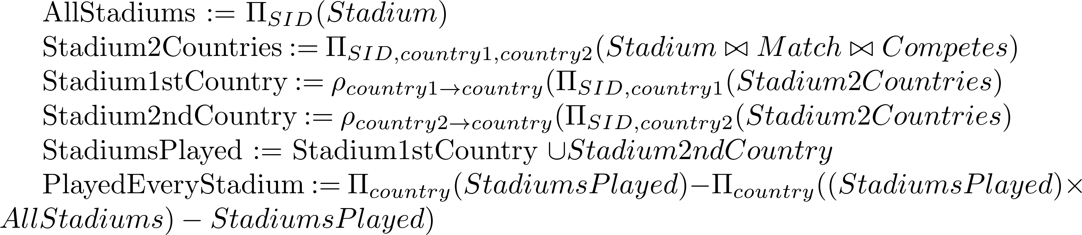

2. Report the MID of the match for which the highest number of tickets was purchased. If there

are ties report all of them.

*Can't be expressed.*

3. Report the PID(s) of the player(s) of the team(s) that didn’t play in any match.



4. Report the SID(s) of the stadium(s) where exactly one match took place.



5. Report the coaches of the teams with the highest difference in the number of goals when competed with each other at a match. If there are ties, report all of them.

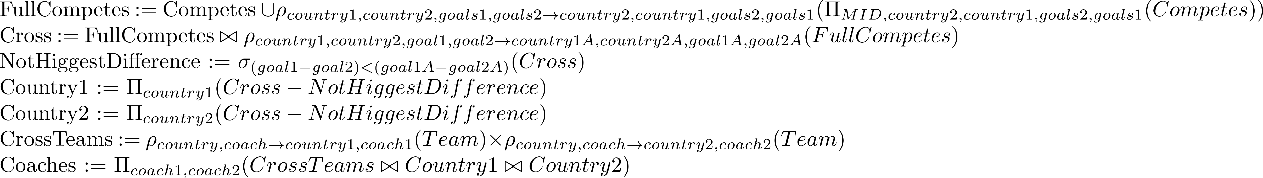

6. Report the fname and lname of the players whose position is ‘D’ and have scored the highest

number of goals among all players (in any team) who play at the same position.

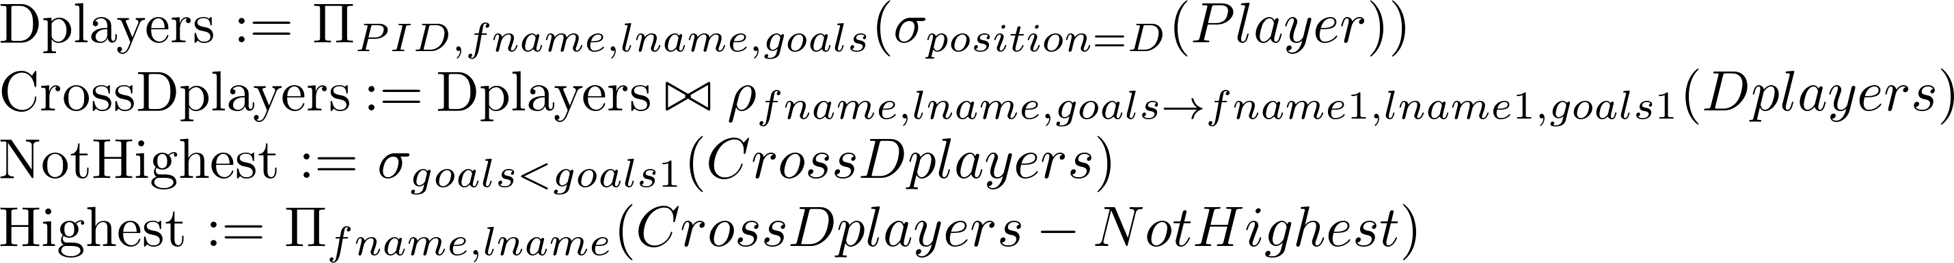

7. Find the winner country of the match for which the very first ticket out of all the tickets in the database was purchased. If there was a tie in the match, report nothing.

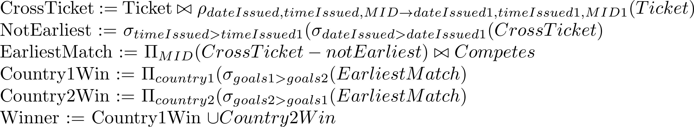

8. Report the fname and lname of the player of the country ‘Spain’ with the second highest number of goals among players of the same country.

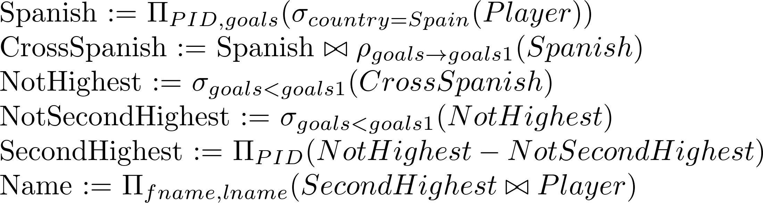

9. Report the MID(s) of the matches for which at least two tickets were bought on the date of the match.

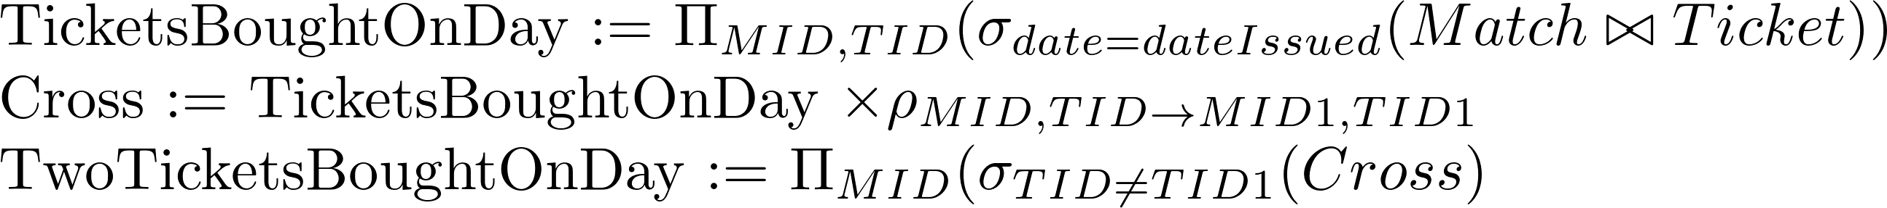

10. Consider all teams that have won at least one match. For each of those teams, report its country, the position of its player with the highest number of goals and the number of goals he has scored.

